June 1, 2022

Dear Sir/Madam:

The water industry in Illinois has a long standing tradition of acknowledging certified water operators for outstanding efforts in the work place and in their communities through the IPWSOA’s Operator of the Year program. In continuance of that tradition it is time to make your 2022 program nominations!

Do you know a water operator that has provided exceptional service, effort and commitment to the water industry and his or her community? Many water operators go above and beyond their required job duties and seldom get recognized. This is your chance to recognize them for their efforts.

All nominated operators are sent a congratulatory letter acknowledging their nomination. Most operators consider it a significant career achievement to be nominated for the award. Be assured that your nomination will mean a great deal to a deserving operator.

Recognizing operators for their contributions is easy! Simply complete the attached one page nomination form and email or mail it to me at the address provided below by August 1, 2022. Persons submitting nominations always remain anonymous.

Thank you for your help in making the 2022 Operator of the Year program a success!

Sincerely,

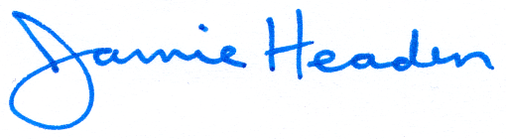
Jamie Headen
Benton & Associates, Inc.
1970 West Lafayette Ave
Jacksonville IL 62650
217-245-4146 office
217-883-2606 Cell
jheaden@bentonassociates.com

OPERATOR OF THE YEAR
AWARD PROGRAM
PLEASE SUBMIT ALL NOMINATIONS BEFORE August 1, 2022 (Please print or type)

NOMINEE’S NAME_______________________________________________________________

HOME ADDRESS_________________________________________________________________
STREET CITY ZIP

HOME PHONE____/___________________ BUSINESS PHONE_____/_______________

WATER SUPPLY: ______________________________________ CLASSIFICATION A B C D
(Circle One)
Give a brief description of the nominee’s duties:

____________________________________________________________________________________________________________________________________________________________________________________________________________________________________________________________________________________________________________________________________
Give a brief supporting statement of nominee:

____________________________________________________________________________________________________________________________________________________________________________________________________________________________________________________________________________________________________________________________________

_____________________________________________________________________________
(Signature and Printed Name )

Jamie Headen
Benton & Associates, Inc.
1970 West Lafayette Ave
Jacksonville IL 62650
217-245-4146 office 217-883-2606 Cell
jheaden@bentonassociates.com

